ONLINE VEHICLE BOOKING MARKET

Nanditha Nambiar

**Abstract**

This project uses a machine learning algorithm to primarily deal with online vehicle reservations.

The ride-hailing and ride-sharing service types are used to segment the market for online taxi services in this study. A ride-sharing arrangement or situation is when two or more persons, typically commuters, share a ride in a motor vehicle. Motorcycles and automobiles are among the various sorts of vehicles, and they all accept a variety of payment methods, including cash and online. The market for online taxi services includes companies (organisations, sole proprietors, and partnerships) that offer passenger transportation by car or van through online reservations or on a booking basis.

This sector consists of businesses that are largely involved in offering taxi services that may be booked using a mobile application. These businesses provide their services to customers through internet channels and mobile apps. Uber and Ola are two examples. The study refers to taxis that have been ordered online or through an app as ride-hailing services. Taxis parked along roadsides are not included in this. Only products and services that are exchanged between parties or offered to final customers are included.

**INTRODUCTION:**

In the twenty-first century, almost everything we use is getting digital, and hiring a cab is no different. In Indian metropolises, Meru Cab services began in 2004. Almost six years later, the Indian market was introduced to app-based rental cab services. The cab service industry underwent a change thanks to app-based cab services. Because it offers door-to-door service, cabs have become one of the most popular modes of transportation. Thanks to technology innovation, clients can now book cabs at reasonable prices with only one click on their smartphones. These app-based services have been extremely popular in densely populated nations like India where parking is a major issue due to a lack of available space as well as during peak hours when public transportation is overcrowded.

A cab used to run empty 30% of the time prior to the introduction of these app-based cab services. While developing the cab application, the agency acted as a buffer or middleman between the drivers and customers by only charging a commission for their "match-making" services. The companies that run these aggregated cab services typically don't own any cars but are connected to the drivers operating local cab services who agree to register with the organisation. These app-based services require an app that is simple to use and requires competent Android/IOS app development skills.

Additionally, a robust, secure cloud architecture that is readily scaleable is required because it will be used by many people, and as a result, the cloud infrastructure must be able to accommodate thousands of connections at once with a strong, wellorganized database. In India, a multitude of applications, like Ola, Uber, etc., offer these services. These businesses offer paid services. On the other hand, there aren't many carpooling apps like rapid ride, which are working to clear the roads of traffic. Carpooling app services undoubtedly reduce carbon emissions on a regular basis and have a positive impact on society, which is inspiring.

The question is whether someone is more likely to employ carpooling or to pick a ride alone out of worry for their privacy. Is the customers' primary concern the price? Or does a person's everyday decision regarding their mode of transportation depend on how environmentally friendly it is? Firms are also choosing cab booking applications to help their businesses grow more quickly than competitors, not just for customers' personal commutes.

**PROBLEM STATEMENT:**

Online Vehicle booking Market

**Data Sources:**

Importing the Dataset: We will import the dataset that we need to use. So here, we are using the Car Rental Data. It can be imported using the below code df=pd.read_csv("CarRentalData.csv")

**Data Pre-processing: (steps and libraries used)**

Importing Libraries:

We will import the libraries for our model, which is part of data pre-processing. The code is given below:

Import pandas as pd

Import numpy as np

Import matplotlib.pyplot as plt

Import seaborn as sns

* [Numpy we](https://www.javatpoint.com/numpy-tutorial) have imported for the performing mathematics calculation.
* Matplotlib is for plotting the graph, and pandas are for managing the dataset.
* Seaborn is for data visualization library, it is based on matplotlib.

**Exploratory Data Analysis:**

Exploratory data analysis, or EDA, is a detailed analysis intended to reveal a data set's underlying structure. It is significant for a business because it reveals trends, patterns, and linkages that are not immediately obvious.

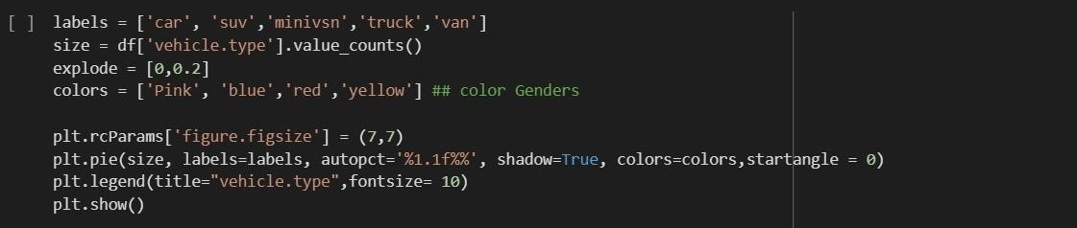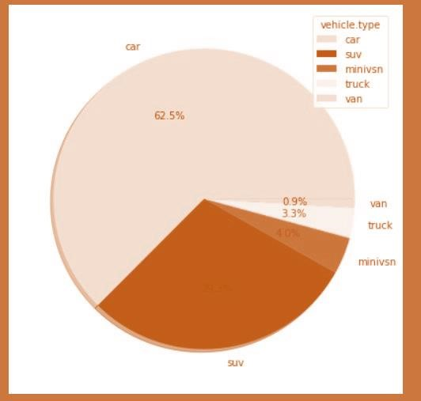

The classification of vehicle type is displayed here. As we can see, cars are the most popular variety, followed by SUVs, minivans, trucks, and vans.

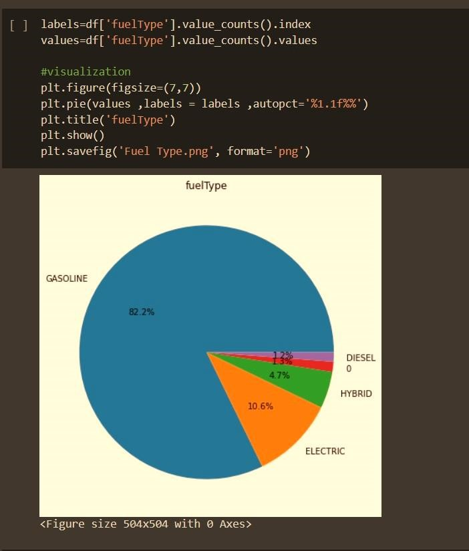

This demonstrates how the fuel types are categorised. As we can see, gasoline is the most common type of fuel.

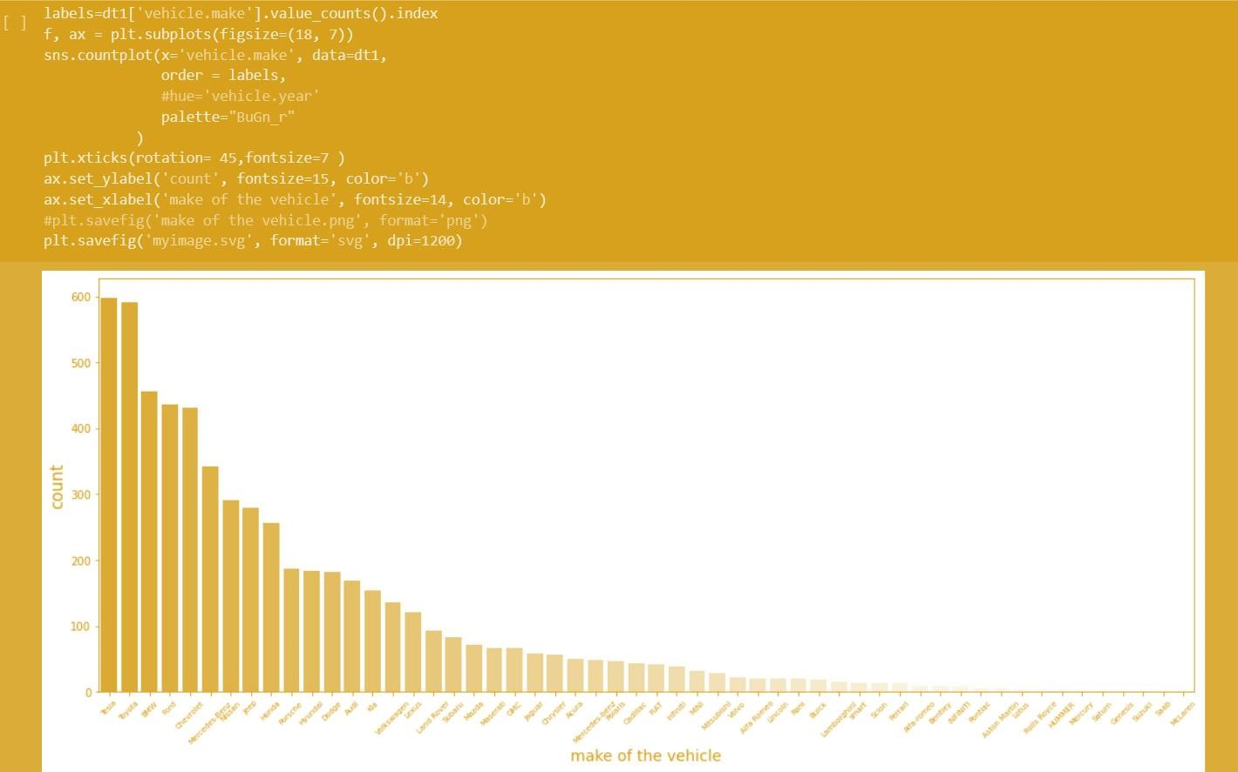

The geographic diversity of the data is depicted in this bar graph. We can observe that the number of data for Tesla and Toyota is at its maximum, while Saab, McLaren, and Suzuki have the lowest number of data.

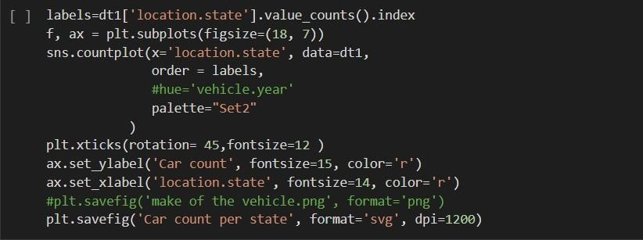

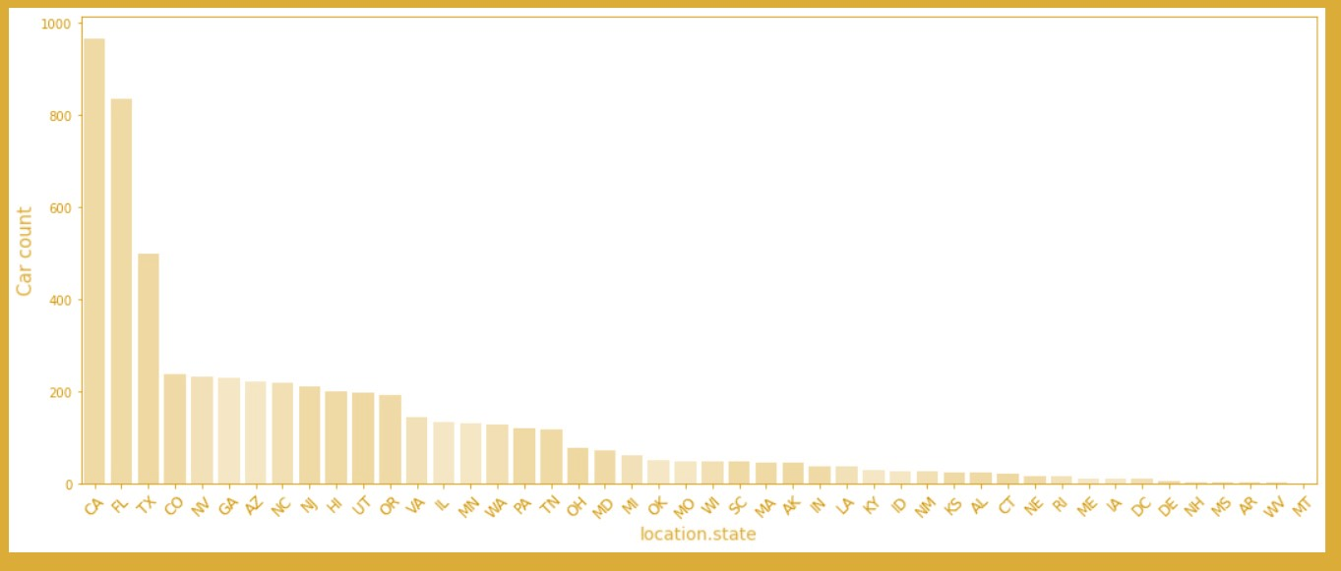

The location (state) where the majority of cars are rented or leased in the US is depicted in this bar chart. The graph shows that the state of CA has a higher count than the states of MT and WW.

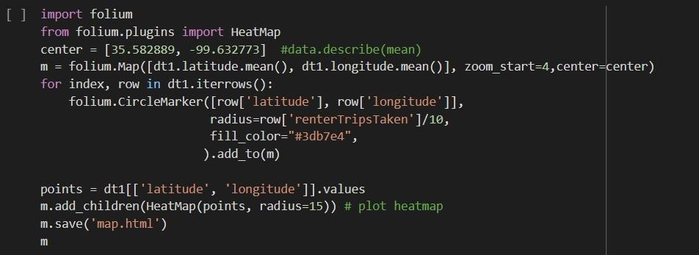

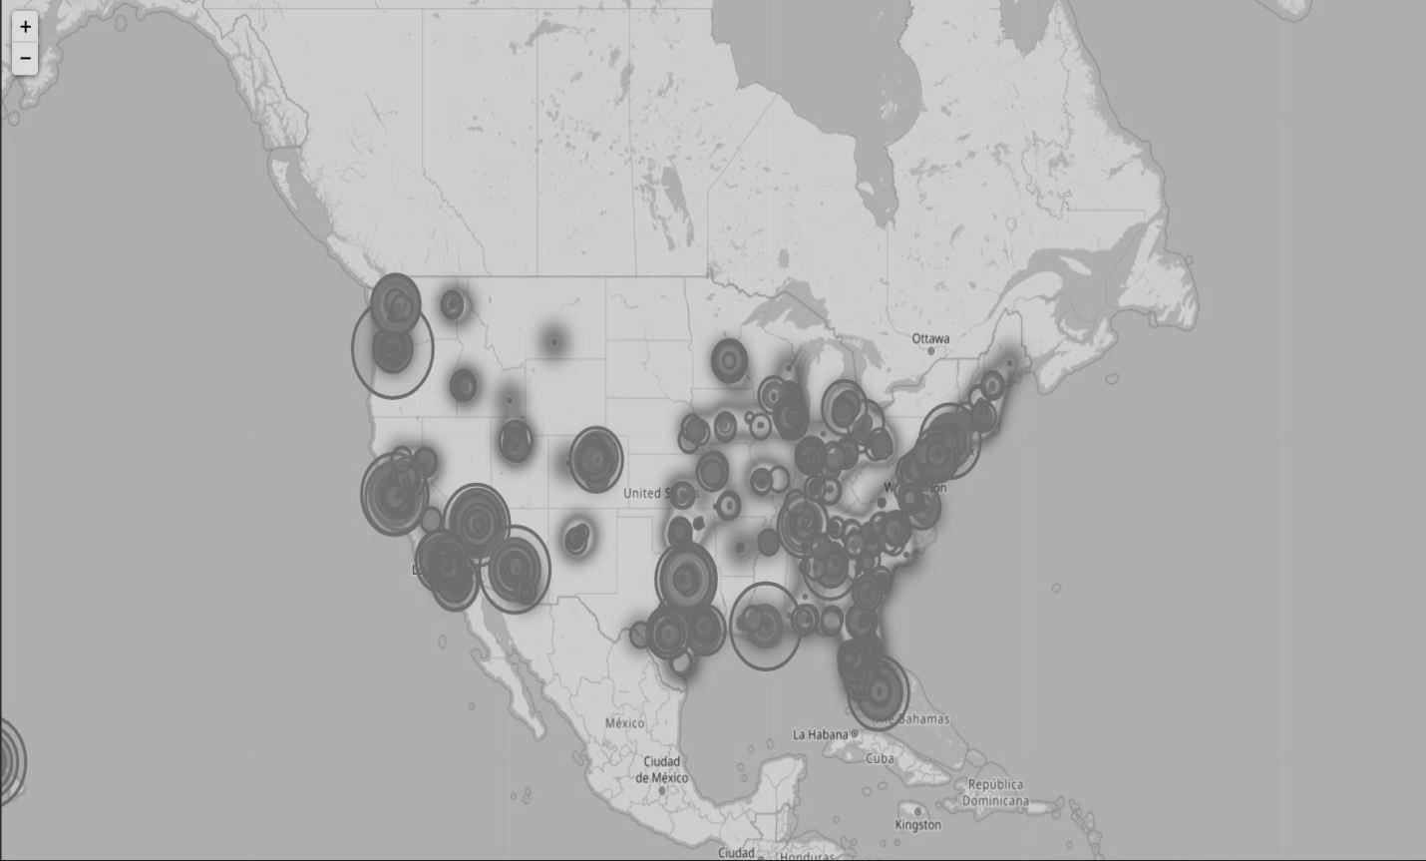

According to the provided dataset, the image shows the longitude and latitude of the US.

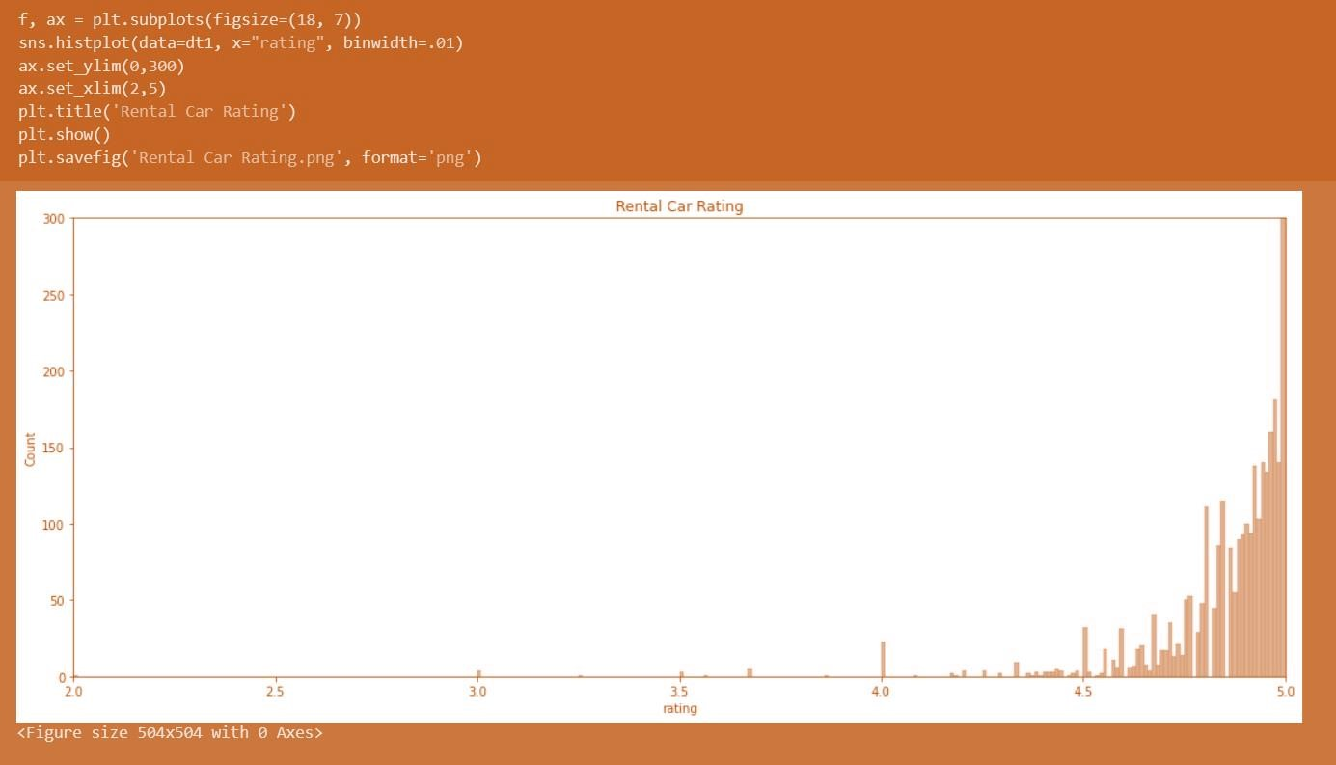

This graph displays the rating given to a specific car based on the provided dataset.

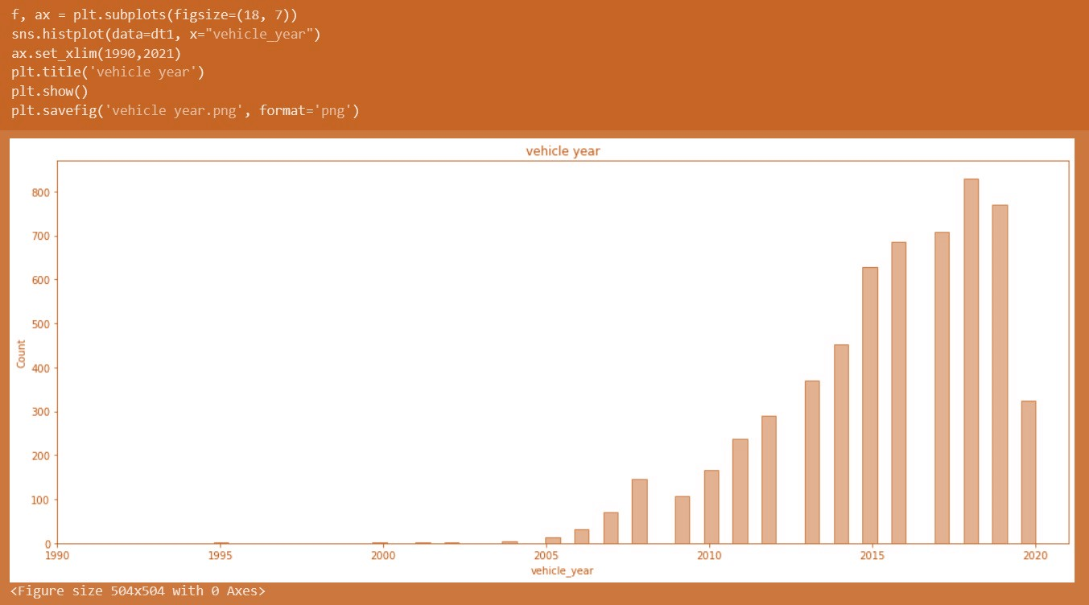

This graph displays the number of annual car rentals. As we can see, the count is at its peak between 2015 and 2020 compared to 2005.

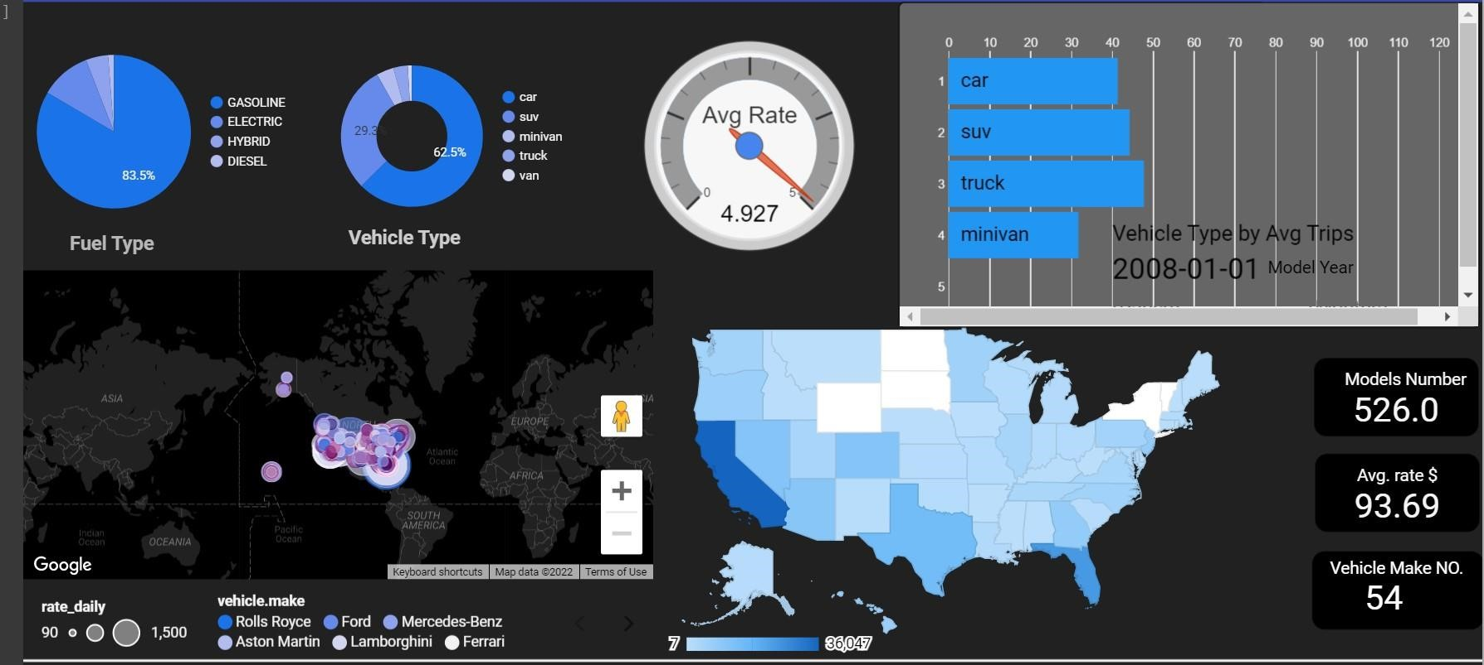

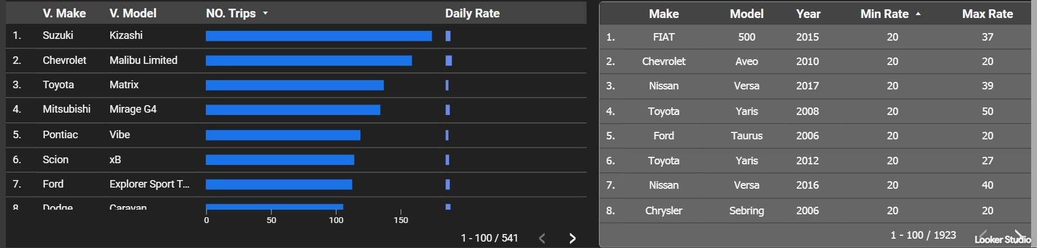

This shows overall display of the model.

**Segment Extraction**

One of the most widely used unsupervised machine learning algorithms for solving classification issues is K means. K Means divides the unlabeled data into multiple clusters based on shared characteristics and patterns. Assume we have N unlabeled multivariate datasets with different attributes from our dataset, such as water availability, price, city, etc. Clustering is a method for categorising datasets into different groups based on shared traits and characteristics. Clusters are the entities that are forming these groups. Unsupervised learning algorithms in machine learning use clustering because it may divide multivariate data into different groups without the need for a supervisor based on a common pattern concealed within the datasets.

In the Elbow approach, the number of clusters (K) is truly variable and ranges from 1 to 10. We are calculating WCSS for each value of K. ( Within-Cluster Sum of Square ). The sum of the squared distances between each point and the cluster's centroid is known as WCSS. The plot of the WCSS with the K value resembles an elbow.

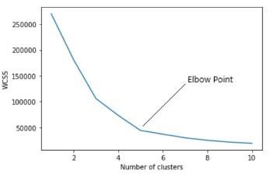

The WCSS value will begin to drop as the number of clusters rises. The highest WCSS value is at K = 1. When we examine the graph, we can observe that it abruptly changes at one point, forming an elbow. The graph then begins to travel nearly parallel to the X-axis from this point on. The best K value, or the most clusters, is the one that corresponds to this location.

**Analysing Market Segments**

**Geographic Segmentation:** To better serve customers in a certain region, marketers segregate a target market according to geography. This kind of market segmentation is based on the geographical entities themselves (countries, states, cities, etc.), as well as a number of other geographic elements, including climate, cultural preferences, population, and more. Geographic segmentation entails dividing up your audience according to the area in which they reside or are employed. Customers can be categorised in a variety of ways, including by their nation of residence, or by more specific geographic divisions, such as city, region, or even postal code.

Even if geographic segmentation is the easiest type of market segmentation to understand, there are still many applications for it that businesses never consider. Depending on your needs as a firm, the area you target should have a different size. Generally speaking, the locations you'll be targeting will be larger the larger the firm. After all, it won't be economical to target each postcode individually with a larger potential audience.

**Demographic Segmentation:** An organization's target market is segmented using the market segmentation technique known as demographic segmentation based on demographic factors like age, gender, education, income, etc. It aids businesses in comprehending their clientele so that their requirements can be better met.

Companies can utilise demographic segmentation to concentrate their time and resources on those groups that have consumers who are most likely to make purchases and are therefore most valuable to them rather than trying to reach the entire market.

The demographic segmentation process involves a number of different factors, including: a. Age: Age is one of the most important variables used within demographic

segmentation as consumers’ preferences and needs differ significantly based on the age group they fall under. When an organization wants to target young adults or teenagers, digital marketing campaigns may prove to be most effective as they appeal to this age group. However, older adults often prefer traditional marketing methods, such as television and magazine advertisements. b. Income: Income levels have a significant effect on consumer purchasing

decisions. Those with higher-income levels may prefer high-end and luxury products. Conversely, individuals with lower income levels may prefer to get products at the best deal and are likely to choose inexpensive products/services. c. Gender: Individuals may identify with different areas of the gender spectrum, like feminine or masculine, and this will have a significant effect on their preferences and purchasing decisions. By understanding which gender your product or service appeals to, you can tailor your marketing campaigns accordingly to meet the needs of your consumers better.

**Psychographic Segmentation :**  Using psychological factors such as personality, lifestyle, social status, hobbies, interests, opinions, and attitudes, psychographic segmentation is a research tool for researching consumers and classifying them into groups.

You can interact with several target audiences using psychographic marketing in the methods that will have the greatest influence on each of them. This strategy avoids wasting time and money on unproductive strategies and facilitates communication with the groups you care about.

For market segmentation, we can utilise psychographics to comprehend: a. How consumers really perceive your products and services b. What consumers really want—and why

1. Gaps or pain points with your current products or services
2. Opportunities for future engagement
3. How to better communicate with your target audience.

**Behavioral Segmentation:**  Behavioral segmentation refers to a process in marketing which divides customers into segments depending on their behavior patterns when interacting with a particular business or website.

These segments could include grouping customers by:

1. Their attitude toward your product, brand or service;
2. Their use of your product or service,
3. Their overall knowledge of your brand and your brand’s products,
4. Their purchasing tendencies, such as buying on special occasions like birthdays or holidays only, etc.

Behavioral segmentation offers marketers and business owners a more complete understanding of their audience, thus enabling them to tailor products or services to specific customer needs.

**Customizing the Market Mix**

The marketing mix refers to the set of actions, or tactics, that a company uses to promote its brand or product in the market. The 4Ps make up a typical marketing mix - Price, Product, Promotion and Place.

1. Price: refers to the value that is put for a product. It depends on costs of production, segment targeted, ability of the market to pay, supply - demand and a host of other direct and indirect factors. There can be several types of pricing strategies, each tied in with an overall business plan
2. Product: refers to the item actually being sold. The product must deliver a minimum level of performance; otherwise even the best work on the other elements of the marketing mix won't do any good.
3. Place: refers to the point of sale. In every industry, catching the eye of the consumer and making it easy for her to buy it is the main aim of a good distribution or 'place' strategy. Retailers pay a premium for the right location. In fact, the mantra of a successful retail business is 'location, location, location’. d.

Promotion: this refers to all the activities undertaken to make the product or service known to the user and trade. This can include advertising, word of mouth, press reports, incentives, commissions and awards to the trade. It can also include consumer schemes, direct marketing, contests and prizes.

All the elements of the marketing mix influence each other. They make up the business plan for a company and handle it right, and can give it great success. The marketing mix needs a lot of understanding, market research and consultation with several people, from users to trade to manufacturing and several others.